Logo Planner

Please complete this logo planner and return to us via email.

To assist our design team in creating your logo and/or corporate identity, we need to find out about your business.
This planning form will help us understand your needs, customers, competitors and market.

Our logo package includes:

- Two to three logo designs concepts to choose from.

- Includes two sets of author’s corrections.

- Your final logo files supplied in EPS, JPEG & PNG formats in color and greyscale modes, suitable for all applications.

- Logo Style Sheet - A guide which outlines your proper logo colors, minimum space requirements
and new corporate fonts.

- You hold on to the intellectual property.

Company Details:

Business name: | Contact person:
Phone: | Email:
Website:

Project Specifics
This section provides a background of your business and corporate identity needs. The more information you provide, the easier it is for us to create a visual identity that will work for you and your customers.

Your Business

General description of your business (what you do).
How long have you been in business?
Your image. Use adjectives to describe your desired business image.
Eg. Highly corporate, professional, friendly, high tech, serious, established, fun, family, business, elite, expensive, inexpensive, exclusive, trendy, big, small etc.
Your target customers.
Who do you want to reach? Please segment these groups if there is more than one. Eg. Blue Chip Companies, Small Business Managers. Tell us about their age, sex, income, occupation, education, lifestyle and purchasing habits.

Design Ideas

Is there a particular style of logo you would like? (Please indicate at least one.)
x | Just font, with  no symbols
 | Font with added meaning
 | Monogram
 | Font inside a shape
 | Abstract icon
 | Regular icon
 | Silhouette
 | Badges or crests
 | Mascot
Logo colors.
Do you have any colors in mind for your logo? (If so, why?) If there’s any colors you don’t like, please also tell us.

Fonts.
Please tick the font types that are most appealing to you. Please note, you aren’t actually choosing what will be used in your logo, this is just to give us an idea of what you like so we can create something even better!
x
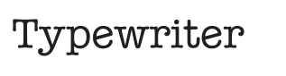
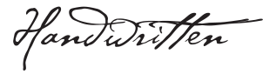
Your design ideas (optional).
What do you like? List any logos and/or design styles you would like and describe why.
Tell us about the personality of your business.

Competitors

Your competitors. Web addresses (if known).
What makes your company different and better than your competitors? What are your points of difference?
Additional comments/suggestions:

